Model for a general mathematical analysis

Here we theoretically derive two results:
- Given the graph generated by a point process, calculate the
Bias = (avg D_ij; i.j connected)/ (avg D_ij; i,j any),
where D_ij is a geographical distance between vertices i,j.
The above formula is a way how to calculate Bias for any given graph. In what follows, we will try to calculate Bias for a lot of graphs, without specifically having any single graph
- Use the above result to evaluate (approximate) the radius of a local neighborhood, (i.e. the distance H that one considers to be the breakpoint between far and close)

To derive the first task, we will basically generalize the method of graph creation devised in Wong. We will assume the following things:
- All points lie in the square of the size 2R x 2R. The parameter R will play a role of a “radius of visibility” – for any particular individual, “nothing” really exists further than the distance R from him/her. This should not be too bounding assumption: all finite networks lie in a finite geographical area.
- The points (vertices of the graph) are distributed by a Poisson point process with parameter. The parameter plays a role of a density (number of points per unit area), the Poisson point process basically means that any region with an area A contains on average 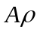 points.
- The parameter R is assumed to be large. More precisely, the number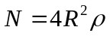 which represents the total number of points in the square will be assumed large (in order to be able to neglect one point if needed). I guess 50 points is a large number for our purposes (plus minus 1 point represents a mistake of about 2%).
- Any two points are connected with a probability f(d), where d is the geographical distance between those points and f is any function with values between 0 and 1. For example, Wong used a function
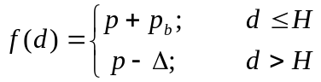
- For the purpose of technical calculation, we assume that the distance between two points with coordinates (x,y) and (s,t) is given by
d = max(I1,I2), where
I1 = min (|x-s|, |x-s+2R|, |x-s-2R|)
I2 = min (|y-t|, |y-t+2R|, |y-t-2R|)
This is just a different way to say that the square has a periodic boundaries (i.e. the whole space looks like a doughnut). And the metric is not the usual metric in a Euclidean sense, rather the maximum (ell infinity) metric.

The last assumption may not be very realistic, yet it is crucial for the simplification of the calculations – it means that the center of the 2R x 2R square is not an exceptional point, in fact anything is a center (due to periodic boundaries), plus R is the maximal distance between any two points and the set of points with a distance d to the center is a square with sides 2d x 2d.

For the last assumption, in a separate file I am attaching a description of a computer simulation that should be able to check whether different metrics and periodic versus non-periodic boundaries significantly change the results (and if yes, by how much)

Calculations:
a) the average distance between any two points can be calculated simply by calculating the average distance from a given fixed point (without loss of generality – b/c of periodic boundaries – positioned in the center) to all other points (this is because of the homogeneity of the Poisson point process).

The point process yields that there are 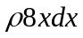 points whose distance to the center is between x and x+dx (where dx is considered very small).
This means that the average distance to the center is
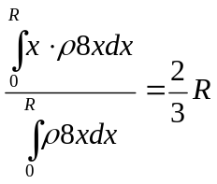
Where the bottom part represents the total number of points () and the top part represents the sum of the distances of all points to the center.

Note that rho cancels out, but mainly 8 (circumference of the square of radius 1) cancels out. This means that when R is very large, using Euclidean metric which would yield the factor  (circumference of a circle of radius 1) would be analogous, with the exception that the Euclidean metric would create errors in the “corners” (which would be negligibly small compared to the rest of the graph)

I am still not clear on the effect of the periodic boundary.

b) similarly, the average length of an edge can be calculated by
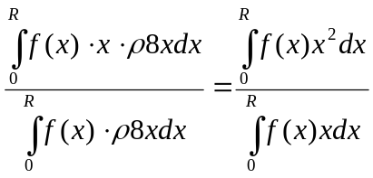
(the expression is basically identical to the above with the addition of the term f(x) that denotes a probability that there is an edge between the two points with geographical distance x)

c) combining the above two results together yields that
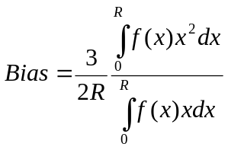 I will denote this formula (*) in a sequel

The above formula provide an estimate of a graph characteristic Bias, based on the function f that describes the density of edges of certain length.

To apply the above general result on the situation as described in Wong, we just evaluate (*) for the function
to get
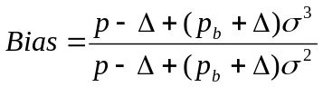 will denote (**)
where 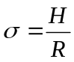is the relative size of what is considered close.

Now, we can proceed to the second and main task: given a graph, determine what is close. In other words, assuming the graph is given by the above construction using the Wong’s function f (for certain parameters p, 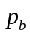,H, ) , determine H in that function.

Note that given any graph, we can calculate Bias of that graph right away. Thus, formula (*) can in principle be used to determine what function f was used to generate such a graph. Specifically for the Wong function, we may use it to determine the parameters in the following way:
- for any H, estimate 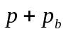 and 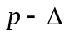 by the Maximum Likelihood Estimate method (which means estimate by the fraction
(#of edges shorter than H)/(# of pairs of points closer than H)
Similarly for
- substitute H and the estimates for , into right hand side of (**)
- repeat for all H in the interval [0,R]
- select H (and the respective estimate) for which the right hand side of (**) is the
closest to the Bias

The above method may be computationally demanding and in its demand it is more or less equivalent to the method shown in Wong (we need a histogram here in the same way Wong needed). However, in many cases, the formula (**) can be used much more efficiently and it still provides good (hopefully, to be judged by the results of simulations) approximation of the neighborhood size H.

CASE 1: The graph is (or can be assumed that is) such that almost all connections of the graph are within the distance H. (I believe small world networks that result from some sort of a regular lattice and changing/adding very few edges to connect to somebody far away is a typical example of such a graph)

In this case, can be approximated by 0 and the formula (**) thus becomes
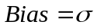 (***)
In other words, the characteristics Bias (that can be calculated very fast and efficiently, without any need for a histogram of edge lengths) IS the estimate of the relative neighborhood size (for this type of graphs).

I think the above (if confirmed by simulations) can/ possibly even should be the main result of the paper. It provides fast and efficient estimation of what is close without any need of the histogram of graph edges lengths. Simply calculate Bias and that is it. The derivation of the formula is presented above (and if the simulations confirm this result, then justification of the assumptions that lead to the analytical results is not much needed anymore)

This result would show that Bias, which can be calculated for any graph, plays an important role for spatial small world networks.

As soon as the numerical simulations confirms this result (or at least show it is not so far from the reality), I will work on specifying as exact as possible (and reasonable) mathematical conditions under which one can approximate and get a formula (***) from formula (**).

CASE 2: The graph is such that H is very small compared to R and there are plenty of long distance connections. I am not very sure whether this has any real world significance. Also, I am not very sure how small H/R is required (less than 0.10 should be enough, possibly even 0.20 could do it). Anyway, it is another case where (**) can be used in a relatively efficient way. And if nothing else, this is somehow related to what Wong was doing.

In this case, can be estimated by 0 and formula (**) becomes
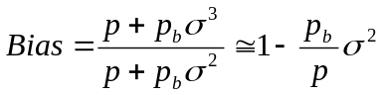 will denote (****)
In this case, p can be estimated by 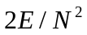where E is the number of edges and N is the number of vertices. One can also try to sample by checking pairs of vertices in short distances (yet for this one needs to have some preliminary believe of what a short distance is). Still, if we want only the estimate of, we can estimate by anything between p and 1. Thus, (****) will become an estimate for as anything in between 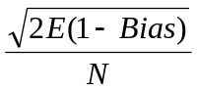 and 